1)To configure your gamil and get notification per triggers

2)create ubuntu server

3)install java and Jenkins through the Jenkins.io webpage commands

4)go to the Jenkins then click manage Jenkins ->system

5)go to gmail notification line SMPT server provide default gmail smtp.gmail.com

6)click on advance then tick the gmail authentication then provide gmail and password

7)these password generated from go to gmail account then clock manage account -> security -> apps password ->create -> paste to the password box

8)fill the smtp port number 465 then

9)click test configuration

10)test configuration mail also come on to your email inbox

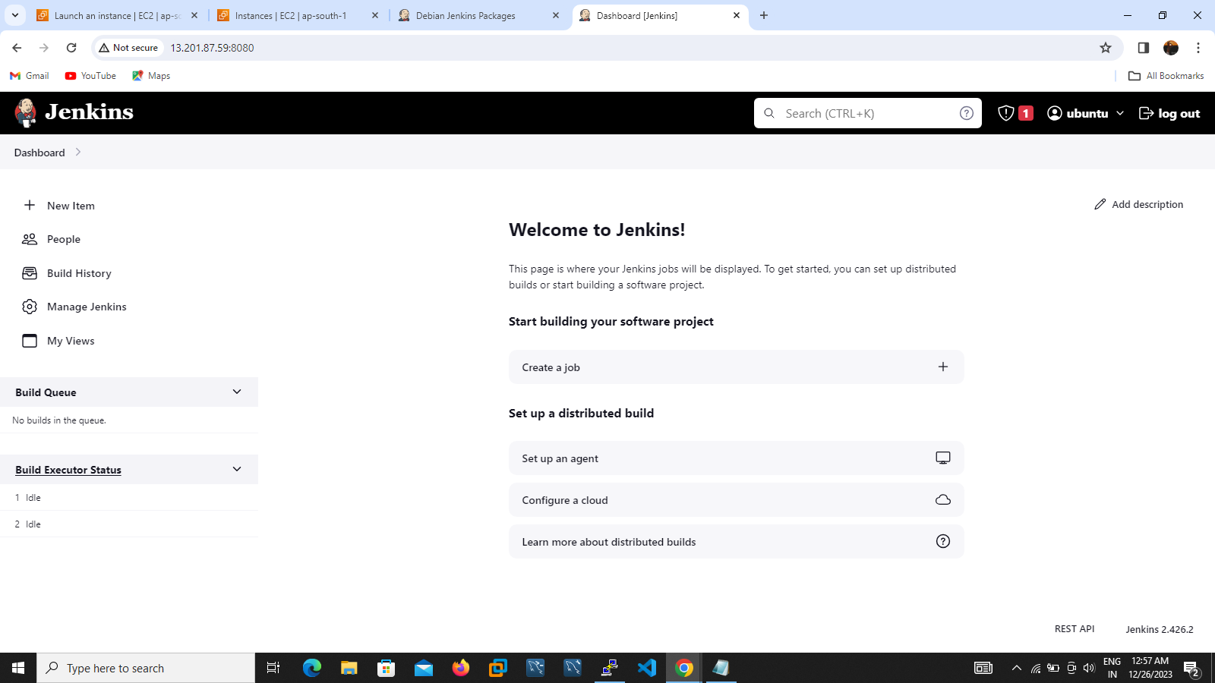

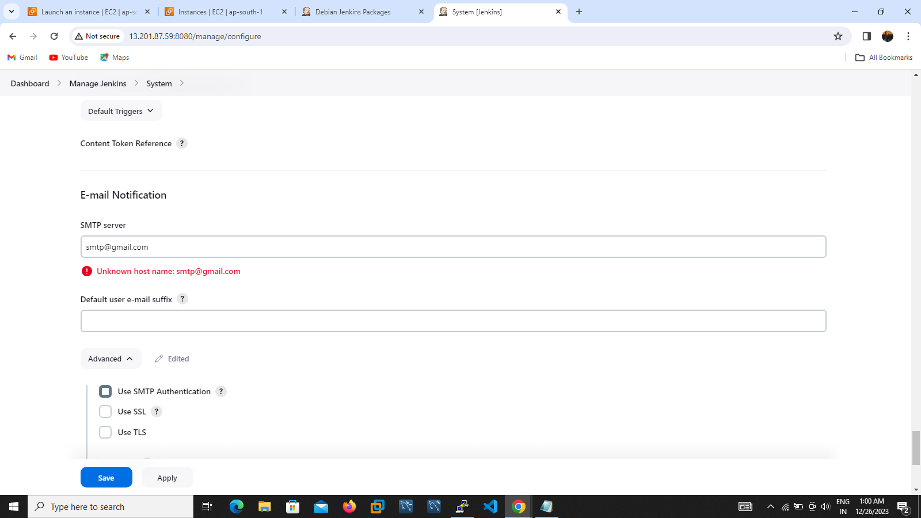

Figure

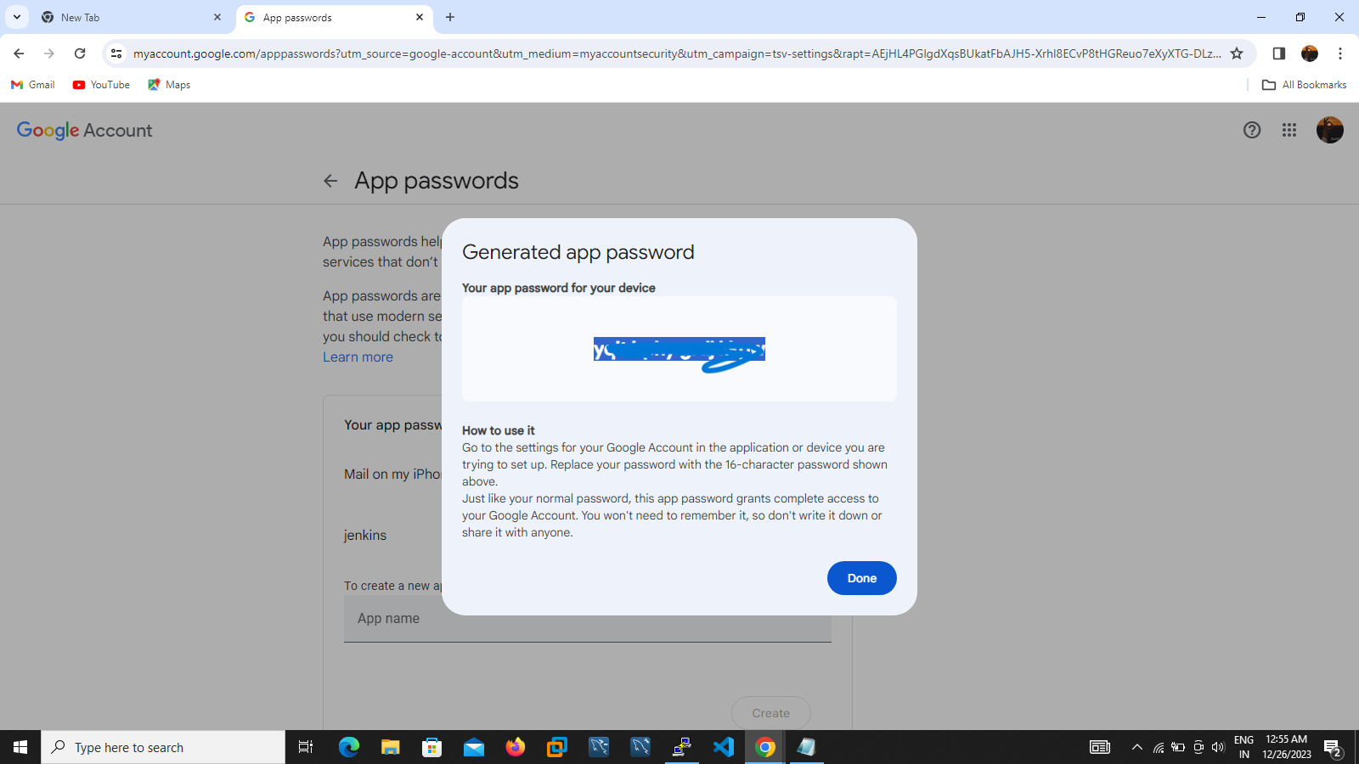

Figure

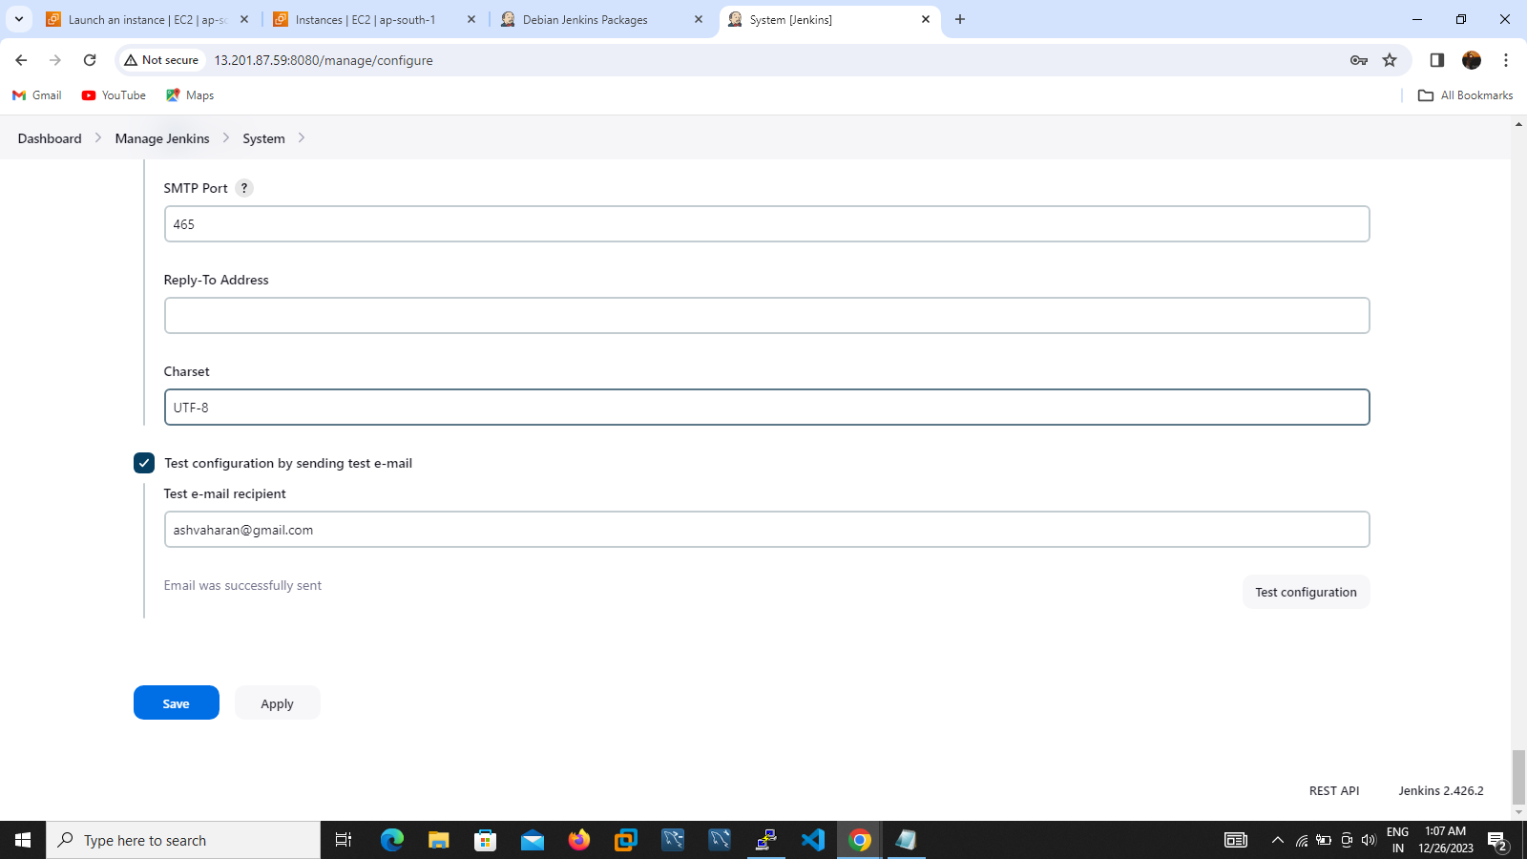

# C:\Users\DELL\Pictures\Screenshots\Screenshot (264).png